Moor Park House Estate Management Ltd

Technology Information

david@mphem.net
oepz5uxcy2mshjm0
sxb1plzcpnl489868.prod.sxb1.secureserver.net

Access to cPanel
o8v1yt3pxvc5
N2G21mWiH@ln

d72axkfknxef
5zzyoz3596zjjefs

http://mphem.net/protected/cd.pdf

URL: 92.205.15.55
Main user: o8v1yt3pxvc5
Password: RqyWfHn8#4BE

Registered Office
MPHEM
The Walled Garden
Farnham
Surrey
GU10 1FA

Telephone

Company Registration Number
9717792

Domain Name
The domain name mphem.net has been registered with TSOHOST.

Hosting
The domain name is associated with Business cPanel hosting from TSOHOST.

Non-indexed pages
Estate Telephone Directory http://www.mphem.net/protected/cd.pdf

A holding web page:
https://www.surreycc.gov.uk/culture-and-leisure/history-centre/marvels/moor-park-farnham
comes up for www.mphem.net

FTP Access
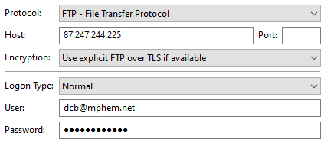
dcb@mphem.net
gif8o5snxarf

Email accounts
archie@mphem.net bhnrsdfn8h29
board@mphem.net Route6542020
david@mphem.net g3ppuu4udx3u
neil@mphem.net
office@mphem.net mui3h8y7dm4s
peter@mphem.net mmd4i7hkjkbt
roger@mphem.net 3h5awnkmi0tq6bwa
sharyn@mphem.net ketnzxttocm2b86t
sysadmin@mphem.net

Forwarding
office@mphem.net >>> archie@mphem.net
office@mphem.net >>> jimcrice@icloud.com
office@mphem.net >>> petereclappison@hotmail.com
office@mphem.net >>> neil@mphem.net
office@mphem.net >>> mallow.land@zen.co.uk
office@mphem.net >>> roger@mphem.net
office@mphem.net >>> sharyn@mphem.net
owner-broadcast@mphem.net >>> david@mphem.net
owner-em@mphem.net >>> david@mphem.net
owner-sh@mphem.net >>> david@mphem.net
peter@mphem.net >>> petereclappison@hotmail.com
archie.bishop@mphem.net >>> archie@mphem.net

Typical Setup in Outlook
Username: sysadmin@mphem.net
Password: ********
Incoming Server: quasar.servers.prgn.misp.co.uk
IMAP Port: 993
Outgoing Server: quasar.servers.prgn.misp.co.uk
SMTP Port: 465

IMAP and SMTP require authentication

Email footer

This is known as a Signature and needs to be added manually to the email client you use. It is mandatory for business purposes to have a footer present that contains certain information. As an absolute minimum it should contain this test and if at all possible ‘our’ logo:

Moor Park House Estate Management Ltd
Registered Office: MPHEM, The Walled Garden, Farnham, Surrey, GU10 1FA
Company Registration No.9717792
Tel: 01252 279 655 (8am-6pm)
DDI: Add if appropriate

Or better still with the design shown below (Replace ‘xxx’ as appropriate):

Kind regards
Mike Clarke
Moor Park House Estate Management Limited
Main: 01252 279 655
Voipfone: 30208619*207
email: mike@mideng.co.uk
This email [and any attachments] is intended solely for the individual[s] to whom addressed. It may contain confidential and/or legally privileged information. Any statement or opinions therein are not necessarily those of Moor Park House Estate Management Limited unless specifically stated. Any unauthorised use, disclosure or copying is prohibited. If you have received this email in error, please notify the sender and delete it from your system. Security and reliability of emails and attachments are not guaranteed. You must take full responsibility for virus checking.
Moor Park House Estate Management Limited registered in England & Wales
Registered Office: MPHEM, The Walled Garden, Farnham, Surrey, GU10 1FA
Company Registration Number: 9717792

Source file of logo


Broadcast Listing - broadcast@mphem.net

99adwatt@gmail.com;
alleman.08@icloud.com;
anitarich@sky.com;
anne.bishop787@gmail.com;
ant@rebusconstruction.co.uk;
antony27@hotmail.com;
audrey@cldmail.co.uk;
candice.light@outlook.com;
carolemcauliffe@icloud.com;
cmcauliffe@talktalk.net;
dickcrowther@aol.com;
david@cyberpictures.net;
fran.brett@talk21.com;
gw@westonmail.co.uk;
helenfrice@icloud.com;
rogbenham@outlook.com;
jane.awford@gmail.com;
jeni.benham@outlook.com;
johnfnash@live.com;
limecroft@hotmail.com;
mallow.land@zen.co.uk;
markpage2@icloud.com;
meadowbrooknz@gmail.com;
michael.r.benham@gmail.com;
mc@mphem.co.uk;
nc@mphem.co.uk;
op@mphem.co.uk;
paulmichaelscanlan@huawei.com;
nalnacs1959@gmail.com;
peter@handscomb.eu;
petereclappison@hotmail.com;
peterw@smarthomes.tv;
richard@metropolitan.co.nz;
rlangridge42@gmail.com;
sally@white-mischief.com;
sandy@forrester-interiors.com;
sn@mphem.co.uk;
sharynnash@hotmail.com;
shirley@wardell.house;
stephendavidgibson@yahoo.co.uk;
tonyrichards@sky.com;
jr@mphem.co.uk;
terryjoa@btinternet.com;
terryjoan@cldmail.co.uk;
tonyrichards@sky.com;
zanne@forrester-interiors.com;
Courtyard Mailing List – cy@mphem.net

archie@mphem.net
candice.light@outlook.com
david@mphem.net
dr.mike.clark@btinternet.com
jeni.benham@outlook.com
mallow.land@zen.co.uk
markpage2@icloud.com
meadowbrooknz@gmail.com
mike.clark@cldmail.co.uk
nalnacs1959@gmail.com
neil@mphem.net
paulmichaelscanlan@huawei.com
petereclappison@hotmail.com
peterw@smarthomes.tv
richard@metropolitan.co.nz

Walled Garden Mailing List – wg@mphem.net

99adwatt@gmail.com
alleman.08@icloud.com
anitarich@sky.com
archie@mphem.net
audrey@cldmail.co.uk
carolemcauliffe@icloud.com
cmcauliffe@talktalk.net
david@cyberpictures.net
dickcrowther@aol.com
fran.brett@talk21.com
jane.awford@gmail.com
jimcrice@icloud.com
johnfnash@live.com
limecroft@hotmail.com
petereclappison@hotmail.com
roger@mphem.net
sharyn@mphem.net
sharynnash@hotmail.com
stephendavidgibson@yahoo.co.uk
terryjoa@btinternet.com
terryjoan@cldmail.co.uk
tonyrichards@sky.com

Shareholders Mailing List – sh@mphem.net

99adwatt@gmail.com
alleman.08@icloud.com
anitarich@sky.com
anne.bishop787@gmail.com
archie@mphem.net
audrey@cldmail.co.uk
candice.light@outlook.com
carolemcauliffe@icloud.com
cmcauliffe@talktalk.net
david@cyberpictures.net
dickcrowther@aol.com
dr.mike.clark@btinternet.com
fran.brett@talk21.com
gw@westonmail.co.uk
helenrice@icloud.com
jane.awford@gmail.com
jeni.benham@outlook.com
jimcrice@icloud.com
johnfnash@live.com
limecroft@hotmail.com
mallow.land@zen.co.uk
markpage2@icloud.com
meadowbrooknz@gmail.com
mike.clark@cldmail.co.uk
nalnacs1959@gmail.com
neil@mphem.net
paulmichaelscanlan@huawei.com
petereclappison@hotmail.com
rlangridge42@gmail.com
sharynnash@hotmail.com
shirley@wardell.house
terryjoa@btinternet.com
terryjoan@cldmail.co.uk
tonyrichards@sky.com
Window Mailing List – window@mphem.net

99adwatt@gmail.com
alleman.08@icloud.com
anitarich@sky.com
archie@mphem.net
audrey@cldmail.co.uk
candice.light@outlook.com
carolemcauliffe@icloud.com
cmcauliffe@talktalk.net
david@cyberpictures.net
david@mphem.net
dickcrowther@aol.com
dr.mike.clark@btinternet.com
fran.brett@talk21.com
info@rogbenham.plus.com
jane.awford@gmail.com
jeni.benham@outlook.com
johnfnash@live.com
limecroft@hotmail.com
mallow.land@zen.co.uk
markpage2@icloud.com
meadowbrooknz@gmail.com
mike.clark@cldmail.co.uk
nalnacs1959@gmail.com
neil@mphem.net
paulmichaelscanlan@huawei.com
petereclappison@hotmail.com
peterw@smarthomes.tv
richard@metropolitan.co.nz
roger@mphem.net
sally@white-mischief.com
sandy@forrester-interiors.com
sharyn@mphem.net
shirley@wardell.house
stephendavidgibson@yahoo.co.uk
terryjoa@btinternet.com
terryjoan@cldmail.co.uk
tonyrichards@sky.com
zanne@forrester-interiors.com

Forward

archie.bishop@mphem.net >>> archie@mphem.net
office@mphem.net >>> archie@mphem.net
office@mphem.net >>> david@cyberpictures.net
office@mphem.net >>> jimcrice@icloud.com
office@mphem.net >>> mallow.land@zen.co.uk
office@mphem.net >>> neil@mphem.net
office@mphem.net >>> petereclappison@hotmail.com
office@mphem.net >>> roger@mphem.net
office@mphem.net >>> sharyn@mphem.net
owner-broadcast@mphem.net >>> david@mphem.net

Service Providers

TSOHOST Domain registration and Hosting
Help Desk: 020 7855 2055 (7am to 12am)
cPanel URL: https://quasar.servers.prgn.misp.co.uk:2083/
Username: mphranet
Password: U2b9w0qmEsO1
Domain: mphem.net
Server: quasar.servers.prgn.misp.co.uk

Cloudscape Connect Ltd Paid by Variable Direct Debit
Account No. 000008676
Help Desk: 0116 274 7360
URL: https://www.cloudscapeconnect.com [Hyperlink Login]
Username: Estate2019
Password: [only known to Mike Clarke]
Broadband Username: VFP1960226@cloudscape.uk
Broadband Password: gu101fa
WAN IP: 92.62.0.181

Instant Ink

HP Customer Support: 020 7660 6027 Account: 7589533982
URL: https://instantink.hpconnected.com/uk/en
Registered email address: office@mphem.net
Password: Route6122023*

Chat Line opening hours:
Monday through Friday 8:30am to 6:00pm Saturday through Sunday 10:00am to 6:00pm (Excluding public holidays)

Voipfone – Rolling Monthly Contract

Voipfone Help Desk 020 7043 5555 or 150
URL: https://www.voipfone.co.uk/login.php?url=%2Faccount.php
Registered email address: sysadmin@mphem.net
Account: 30208619
Password: Route612*
Memorable Word; trolleybus
Free telephone number: 05603 869 268

Voipfone Details
Each DDI number associated with an extension number costs £3 + VAT per month. VoIP always requires a suitable broadband service. In the event of a power failure and/or loss of broadband service, incoming calls are diverted to a failover number which if unavailable/unanswered will cascade down into your voicemail box. To listen to your own stored voicemails, dial 1571 from your VoIP phone.
Extension to extension calls are free and also to anyone else on the Voipfone network. Calls made to a 01/02/03 number are roughly 2ppm and to a mobile 12ppm. Anything else costs more. Service calls like 101 (Police non-emergency) are free. To check you have a VoIP service, dial 155 (Test VoIP facility).
To install the service on an iPad, go to https://www.voipfone.co.uk/softphone_download.php and select the button: Download for iPhone and follow the instructions

Incoming calls and Voicemail
Your phone will ring for 25 seconds (variable) and if not answered, the caller will be invited to leave a message. You retrieve these messages by dialling 1571 and working through the voice menu. Alternatively, the same messages will be found in an email sent to you from Voipfone Voicemail <voicemail@voipfone.co.uk> as an attachment. Your extension can be tagged to immediately go to Voicemail if called at an unreasonable hour (not recommended if Hosted PABX number is used by the door/gate entry system). Unreasonable hours are currently defined as being outside of 08:00 hours to 18:00 hours.

Because incoming calls to the MPHEM Office phone 01252 279655 simultaneously rings a group of numbers, a different retrieval number of 1573 is used selecting the group number 1#, otherwise all the above applies. Messages left uses the email address of office@mphem.net

Making Calls
Dial the number, which if it is on the public network will usually require the area code to be used, and press the green button. Calls from any extension are charged to the MPHEM communal account. Extension to extension calls are free and also to anyone else on the Voipfone network.

Call Charges
Service Used | Pence per minute  Ex VAT | Pence per minute  Inc VAT
01, 02, 03 | 1p | 1.20p
0800 & 0808 | FREE | FREE
Internal and System Calls | FREE | FREE
O2, EE, Three, Virgin and Vodafone | 10p | 12p
Lyca and Others | 20p | 24p
There is no connection charge, with per second billing after the first minute.

In-call Feature Codes
- ## Used to transfer a call.
- #0 Starts and stops Call recording. Charged at 2.5ppm + normal call charge of 1.2ppm.
- #1 Places a call on hold. # will remove from hold.
Do this if you do not want the caller to hear your private conversations.
- ‘R’ Key Used to initiate a call transfer process and other facilities.

Short Code Service Numbers
- 112 Emergency Services
- 999 Emergency Services
- 101 Non-emergency Police number
- 123 Gives date and time
- 141 Withhold your number
- 150 Voipfone help desk
- 152 Voipfone Echo test; shows how good your connection to Voipfone is.
- 154 Reads back your account minutes and balance.
- 155 Confirms that you have set up your phone correctly.
- 1470 un-withhold your number
- 1471 Plays back the last number that called you.
- 1571 Voicemail for the extension you are using.
- 1572 Master Group Messages. [The Master Group is currently not used].
- 1573 Voicemail for Groups 1 [01252 279655] and 2 [01252 279323].

Voicemail Menu when using 1571 – Includes making unavailable recordings
- 1 Read voicemail messages
  - 4 Play previous message
  - 5 Repeat current message
  - 6 Play next message
  - 7 Delete current message
  - 8 Forward message to another mailbox
  - 9 Save message in a folder
    - 0 Save in new Messages
    - 1 Save in old Messages
    - 2 Save in Work Messages
    - 3 Save in Family Messages
    - 4 Save in Friends Messages
- 2 Change folders
  - 0 Switch to new Messages
  - 1 Switch to old Messages
  - 2 Switch to Work Messages
  - 3 Switch to Family Messages
  - 4 Switch to Friends Messages
  - # Disconnect from the Voice server
- 3 Advanced Options
  - 1 Reply
  - 3 Information about the caller
  - 5 Send Message
- 0 Mailbox options
  - 1 Record your unavailable message
  - 2 Record your busy message
  - 3 Record your name
  - 4 Record, or remove, your temporary message [used for unusual situations]
  - 5 Change your password
  - * Return to the main menu
  - After recording a message [incoming message, busy/unavailable, greeting, or name]
    - 1 Accept
    - 2 Review
    - 3 Re-record
While listening to a recorded voicemail message, Press # to fast forward, or * to rewind by skip increments.
- * Help (except during message playback which will restart the message)
- # Exit (except during message playback which will Skip forward)

Voicemail Menu when using 1573
- 2 Change folders
  - 0 Switch to new Messages
  - 1 Switch to old Messages
  - 2 Switch to Work Messages
  - 3 Switch to Family Messages
  - 4 Switch to Friends Messages
- 0 Mailbox options
  - 1 Record your unavailable message
  - 2 Record your busy message
  - 3 Record your name
  - 4 Record, or remove, your temporary message [used for unusual situations]
  - 5 Change your password
  - * Return to the main menu
  - After recording a message [incoming message, busy/unavailable, greeting, or name]
    - 1 Accept
    - 2 Review
    - 3 Re-record
While listening to a recorded voicemail message, Press # to fast forward, or * to rewind by skip increments.
- * Help (except during message playback which will restart the message)
- # Exit (except during message playback which will Skip forward)

Router

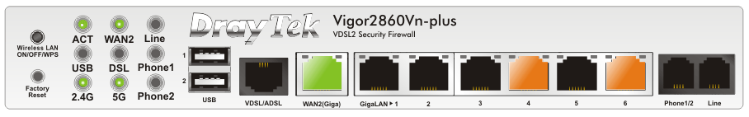

Model: Vigor2860Vn+
URL: 192.168.86.1
Userid: admin
Password: Trolleybus654*

VPN Access:
URL: 92.62.0.181
Userid: david2
Password: Elstead2008

Connecting to Office Network [LAN]

SSID 2.4GHz: MPHEM-Office
Password: TheWalledGardenFTTP

SSID 5GHz: MPHEM-5G
Password: SimpleOne2023

Printer
HP Customer Support - Monday through Friday 8:00 a.m. - 6:00 p.m. – 0

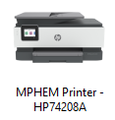
Host Name: HP74208A
IP Address: 192.168.86.86
PIN: 76849155
MAC Address: E0-73-E7-74-20-8A
Port: 4

Wi-Fi Direct Status: On
Channel: 6
Wi-Fi Direct Name: DIRECT-8B-HP OfficeJet Pro 8020
Wi-Fi Direct Password; 329392165116
ePrint: 9422q6872rt@hpeprint.com

Warranty Details
Coverage type Factory warranty
Service type HP HW Replacement Support
Start date September 01, 2023
End date August 31, 2024
Service level Standard Material Handling, Global Coverage, Std Office Hrs Std Office Days,
HP Ships to Customer Site, NextAvail TechResource Remote, Normal Product Lead Time, Standard Parts Logistics, Pickup by HP
Deliverables Advance Product Exchange, Remote HW Diagnosis & Support
Office Phone (Gigaset S850A-GO)

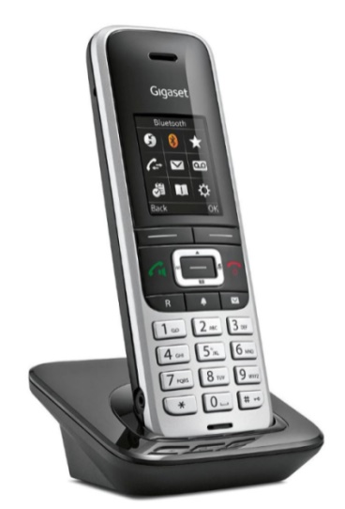
The ‘R’ key is used to access the advanced features of VoIP.
The Green key, if briefly pressed while on a call, turns the speaker on.

VoIP Number: 01252 279 655 Extension: 200
No DDI number

Access to the phone’s GUI is through its web address: 192.168.86.89
Password: 1111
MAC Address: 58-9E-C6-01-63-BE
To configure personal info services (e.g., Weather, eBay, News, ...) go to www.gigaset.net/myaccount

For manual authentication in Gigaset.net, please use the information below.
Username: 21285168034#9
Password: MpqeFHUz

Gigaset help desk telephone number: 020 369 53111

The manual for this phone is here:
https://www.gigaset.com/en_en/cms/gigaset-phones-smartphones-and-smart-home-alarm-systems/service/support-detail/gigaset-s850a-go.html

Landlord's Telephone Lines
Telguard, Kingfisher House, Northwood Park, Gatwick Road, Crawley, West Sussex, RH10 9XN
Login Email: office@mphem.net
Password: FT8KRRn2x
Direct Debit Management Portal: https://telguardonline.co.uk/
Account Management & Invoice Portal: https://login1.uk/

WG Gate 07430 525931
WG Main Foyer (Front) 07430 526398
WG Main Foyer (Rear) 07476 856955
WG 2-5 Foyer 07430 527525
WG 6-11 Foyer 07430 527482
WG 12-13 Foyer 07430 528086
MH Gate 07430 525930
MH Foyer 07430 527654

Cloudscape
Lift Serving MH 1-3 01252 721222
Lift Serving WG 4-5 01252 725864
Lift Serving WG 2 01252 737734
Lift Serving WG 10-11 01252 719138

Voipfone
URL: https://my.voipfone.co.uk/#!/services/pbx/extensions
Account: sysadmin@mphem.net
Password: Route612*
Memorable Word: trolleybus

DV Lines
Number Destination Name
01252 279121 Group 4 Sharyn Nash
01252 279160 201 Stephen Gibson
01252 279240 Group 5 Roger Benham
01252 279323 Master Group Archie Bishop
01252 279411 204 David Bradley
01252 279611 215 Richard Crowther
01252 279654 203 Jim Rice
01252 279655 Group 1 Generic Number
01252 279850 222 Neil Curtis
05603 869268 Group 2 MH Gate

Extension Numbers
Ext Location Device Groups PW
200 - MPHEM Office Gigaset 1 & 2 692100
201 - Stephen Gibson Gigaset 1 & 2 470912
202 - Archie Bishop Gigaset Master 163039
203 - Jim Rice Mobile 286539
204 - David Bradley snom375 1 & 2 931889
205 - Peter Clappison Landline 560746
206 - Sharyn Nash iPhone 4 155250
207 - Roger Benham iPad 1 5 286539
208 - Archie Bishop iPad 831672
209 - Archie Bishop iPhone 300007
210 - WG Gate O2 Mobile 505222
211 - Oliver Penfold Mobile 517619
212 - David Bradley Gigaset 1 & 2 255244
213 - MH Gate O2 Mobile 616286
214 - Roger Benham iPad 2 5 591154
215 - Richard Crowther Mobile 1 & 2 062303
216 - Sharyn Nash iPad 4 654235
217 - David Bradley snom385 1 & 2 440582
218 - Sharyn Nash iPad 1, 2 & 4 052551
220 - Roger Benham iPad 1, 2 & 5 900938
222 - 752746

Electricity Accounts

Meter  Number | Customer Number | Meter Location | Serves  Information Gathered from the Consumer Unit
K10C00437  50% BSC  50% ESC | 1194716418 | MH Services Room | Lift, Fire Alarm Panel, Building’s Communal (including basement) of Lighting, Power & Emergency Lighting, Foyer Door Entry System, Exterior Lighting, Gate and its control Panel, TV Distribution System.
K11C01099  100% BSC | 5089095411 | Services Cupboard by WG2 | Lift, Fire Alarm Panel, Door Entry System, Building’s Communal Light, Power, Heating & Emergency Lighting.
D10C03333  100% ESC | 9203295413 | MH Garages (Brick Hut) | Opening consumer unit not done.  Services thought to be for:  MH Garages, some exterior lighting, MH Garages gate
K10CO5062  50% BSC  50% WG | 2651207412 | Services Cupboard by WG8 | Lift, Fire Alarm Panel, Building’s Communal Light, Power, Heating & Emergency Lighting, Door Entry System, Communal TV Power, Feed to Communal area in Apartments #12 & #13 with onward feed to the fountain in Moor Park grounds
K11C02640  100% BSC | 2215806417 | Services Cupboard by WG6 | Lift, Fire Alarm Panel, Gates (including controls), Door Entry System, Building’s Communal Light, Power, Heating & Emergency Lighting, Office Heat, Light & Power, and Communal TV Power.
K11C02645  50% BSC  50% ESC | 3874226411 | Carpenters Workshop | Room Power Sockets, Room Lighting, Sewage Treatment Control Panel, Garage Sockets, Radiators, Harvester Tank, Garden Lights, Sink Heater, Fountain, Fire Alarm Panel, Cycle Store Lighting (Feed from a Garage), WG Driveway Lighting.

Electricity Account

Previously SSE
URL: https://my.sse.co.uk/your-account/login
Username: office@mphem.net
Password: eight2six

Now with OVO
URL: https://my.ovoenergy.com/login
Username: mike@mphem.net
Password:

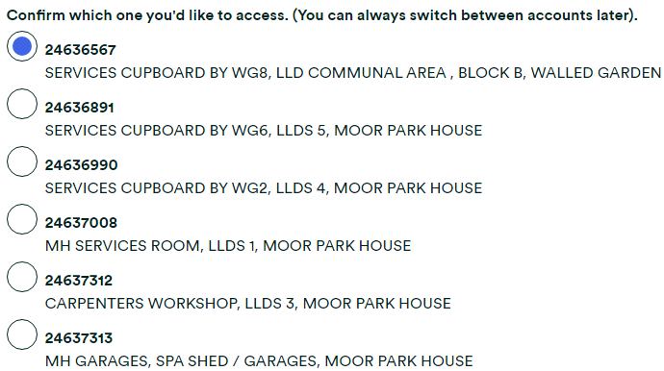
Next reading required: 28 Sep 2023

24636567 - SERVICES CUPBOARD BY WG8
£825.59 in debit Paying £112.00 on the 4th of each month

24636891 - SERVICES CUPBOARD BY WG6
£60.60 in credit Paying £72.00 on the 4th of each month

24636990 - SERVICES CUPBOARD BY WG2
£208.93 in credit Paying £70.00 on the 4th of each month

24637008 - MH SERVICES ROOM
£956.33 in credit Paying £126.00 on the 4th of each month

24637312 - CARPENTERS WORKSHOP
£609.61 in credit Paying £400.00 on the 4th of each month

24637313 - MH GARAGES
£95.90 in credit Paying £50.00 on the 4th of each month £168.00

£1105.78 £830.00
Smart Metering - As of 17/09/2023 only two smart meters have been fitted.

SSE Account Number | OVO Account Number | Old Meter Number | New Meter Number | Location
11947 16418 | 24637008 | K10C00437 |  | MH Services
22158 06417 | 24636891 | K11C02640 |  | WG6
26512 07412 | 24636567 | K10C05062 |  | WG8
38742 26411 | 24637312 | K11C02645 |  | Workshop
50890 95411 | 24636990 | K11C01099 | Unknown | WG2
92032 95413 | 24637313 | D10C03333 | Unknown | MH Garages

Gas Account
URL: https://www.britishgas.co.uk/identity/
Account: office@mphem.net
Password: [Eight2Six]

Supplier British Gas
Tariff name Standard
Tariff type Variable
Payment method Monthly Direct Debit
Standard unit rate
Standing charge
Tariff ends on Not applicable
Price guaranteed until Not applicable
Exit fees (if you change supplier before the end date) Not applicable
Discounts & additional charges Not applicable
Additional products or services included Not applicable

Illustrative gas cost for this tariff
Assumed annual consumption 12,000 kWh
Estimated annual cost
Team Viewer for Windows


Download for free here:
https://www.teamviewer.com/en/?pid=google.tv_free.s.gb&gclid=CjwKCAjwscDpBRBnEiwAnQ0HQLJ0NHbRBT6LuT0W4Hnt_Ekfy0KzSwleIEKOeSiwUzj1V-o0TwvwjhoCrm8QAvD_BwE

Softphone on an iPad, iPhone, Laptop or Desktop


Using an iPad or iPhone
The software is found here: https://www.voipfone.co.uk/softphone_download.php and select the button: Download for iPhone and follow the instructions.
Configuration requirement of userid [like 30208619*204] and password [like 123456]
More information here:
https://www.voipfone.co.uk/support-how-to-use-the-softphone-iphone-app.php


Using a laptop or desktop running Windows 10
The software is found here: https://www.voipfone.co.uk/softphone_download.php and select the button: Download for Windows and run the software with all its default settings.
If a Windows security box pops up, click 'unblock'.

Configuration requirements:
  - Double click on the Zoiper icon
  - Open the settings page by clicking on the little spanner icon
  - Click 'Add new SIP account'
  - Enter your name (anything)
  - Domain: sip.voipfone.net
  - Userid: [like 30208619*204]
  - Password: [like 123456]
  - Caller ID: The name you wish people to see when you call them
  - Click 'Apply' then 'OK'

The phone should report: Registered – Diagnostic tests: 155 [Configuration] and 152 [Sound].

Gigaset S850A GO base unit

Model: Gigaset S850A GO
Host Name: S850A-GO
Fixed IP Address: 192.168.86.89
Password: 1111
MAC Address: 58:9E:C6:01:63:BE

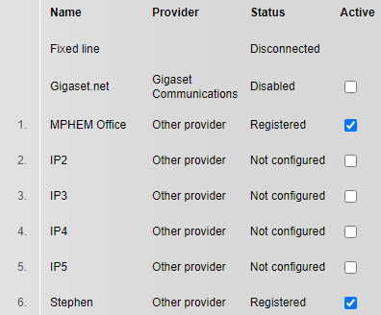
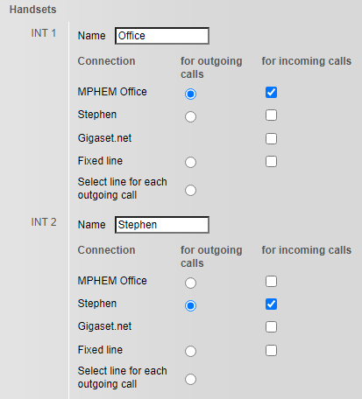
Door / Gate Entry System
From the Gigaset phone you can open the security gates/doors based on this rule base:
- If the visitor is using the console unit to call you, then dialling 3 will open whichever door or gate the visitor is standing by. The intercom only allows about 30 seconds of conversation before terminating the call but you can use the call back facility to have a longer conversation with the person wishing to gain entry.
- You can use the table below to call individual doors/gates which will auto answer whereupon you can dial 3 to open the gate/door. You must be registered on the system with the phone number you are using to do this task and that number is more commonly the number which is dialled by the console unit to alert you that you have a visitor.
WG Gate 07430 525931
WG Main Foyer (Front) 07430 526398
WG Main Foyer (Rear) 07476 856955
WG 2-5 Foyer 07430 527525
WG 6-11 Foyer 07430 527482
WG 12-13 Foyer 07430 528086
MH Gate 07430 525930
Fobs
See Separate documentation

Changes and Additions to the Door Entry System [Videx]
See Separate documentation

Location Map
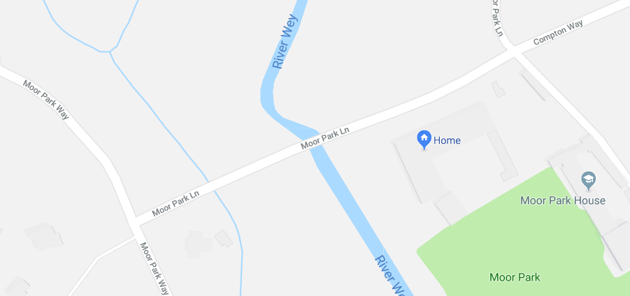

Addresses on the Post Office Database locate within the Estate

Moor Park House Estate Management, The Walled Garden, Farnham, GU10 1FA
1 The Walled Garden, Farnham, GU10 1FA
2 The Walled Garden, Farnham, GU10 1FA
3 The Walled Garden, Farnham, GU10 1FA
4 The Walled Garden, Farnham, GU10 1FA
5 The Walled Garden, Farnham, GU10 1FA
6 The Walled Garden. Farnham, GU10 1FA
7 The Walled Garden, Farnham, GU10 1FA
8 The Walled Garden, Farnham, GU10 1FA
9 The Walled Garden, Farnham, GU10 1FA
10 The Walled Garden, Farnham, GU10 1FA
11 The Walled Garden, Farnham, GU10 1FA
12 The Walled Garden, Farnham, GU10 1FA
13 The Walled Garden, Farnham, GU10 1FA

1 Moor Park House, Moor Park House Way, Farnham, GU10 1FH
2 Moor Park House, Moor Park House Way, Farnham, GU10 1FH
3 Moor Park House, Moor Park House Way, Farnham, GU10 1FH
The Old Chapel, Moor Park House Way, Farnham, GU10 1FH

1 The Courtyard, Moor Park House Way, Farnham, GU10 1FE
2 The Courtyard, Moor Park House Way, Farnham, GU10 1FE
3 The Courtyard, Moor Park House Way, Farnham, GU10 1FE
4 The Courtyard, Moor Park House Way, Farnham, GU10 1FE
5 The Courtyard, Moor Park House Way, Farnham, GU10 1FE
6 The Courtyard, Moor Park House Way, Farnham, GU10 1FE
7 The Courtyard, Moor Park House Way, Farnham, GU10 1FE
8 The Courtyard, Moor Park House Way, Farnham, GU10 1FE
9 The Courtyard, Moor Park House Way. Farnham, GU10 1FE
Caravan (Building Site), Moor Park House Way, Farnham, GU10 1FE

Nearby Properties
Appledore, Moor Park Lane, Farnham, GU10 1QP [Between Moor Park House Way & The Walled Garden]
Compton Lodge, Moor Park Way, Farnham, GU9 8EN [Corner of Moor Park Lane & Moor Park Way]

A new installation of Piwigo 2.10.2 has been completed. The details of the installation are shown below:
Path: /home/mphranet/public_html/photolibrary
URL: http://mphem.net/photolibrary
Admin URL: http://mphem.net/photolibrary/admin.php
Admin Username: admin
Admin Password: elstead2008
Admin Email: david@mphem.net
Password: Route6542020
MySQL Datase: mphranet_piwi641
MySQL DB User: mphranet_piwi641
MySQL DB Host: localhost
MySQL DB Password: ********
Update Notification: Enabled
Auto Upgrade: Enabled (Major and Minor) Automated Backups : Once a month Backup Rotation : 4 Time of Installation: July 8, 2020, 4:02 pm

https://banking.suitsmecard.com/auth/login
100617591478
Route6542023*
06/10/1939
7644

Account Number 01961444
Sort Code 23 03 63

