Computer Installation and Telephone Services Fact Sheet
Company: Pond UK Version: Thursday, 14 August 2014

Business Address:
4, Riverside Park Industrial Estate
Dogflud Way
Farnham
Surrey
GU9 7UG

VAT No: GB Company Registration Number:

Phone Number: 01252 756120 [Rings all VoIP identities]
Identities: 201123472 to 201123474

VoIP Summary
When 01252 756120 is called, all the identities shown below ring. Unanswered calls will be picked up on mailbox 10463 with the associated email account of info@ponduk.co.uk

Identity | Identity  Password | Voice Mail Box | Voicemail  email address | Phone Location | Logon ID | Password | Identity Password
201123472 | puk31415 | - | Not currently required | Warehouse | - | - | -
201123473 | puk31415 | 10462 | gary@ponduk.co.uk | GF Office | water | deep | 5050
201123474 | puk31415 | 10461 | darren@ponduk.co.uk | GF Office | apple | fiveaday | 1618

DDI Information
192.168.120.1 201123472 DDI number is 08455 578527 Warehouse POTS from line 2 of router
192.168.120.20 201123473 DDI number is 01252 756123 Gary snom320
192.168.120.24 201123474 DDI number is 01252 756121 Darren snom320
Draytel Registrations
8490739 u]eO52GF pond@aveuk.net route654 Router

Historical Information
ponduk2014 | route654 | 3366

Darren – 201123472 – 192.168.4.81
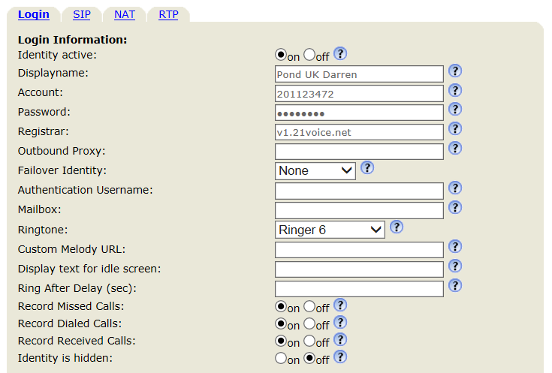
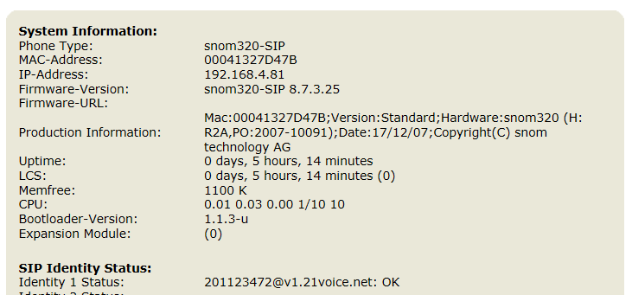

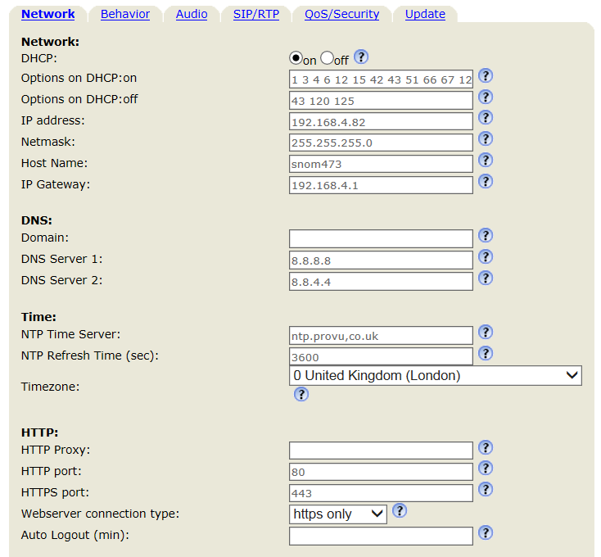

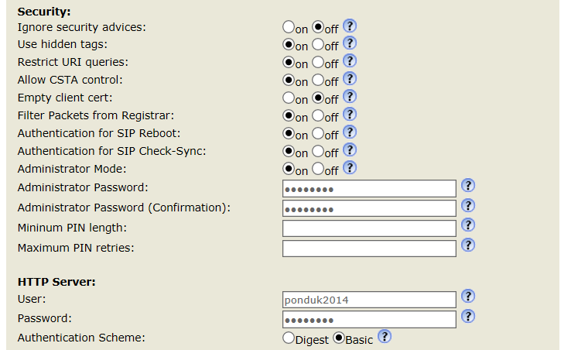

Administrator Password: 3366 HTTP Password: route654



Garry – 201123473 – 192.168.4.82
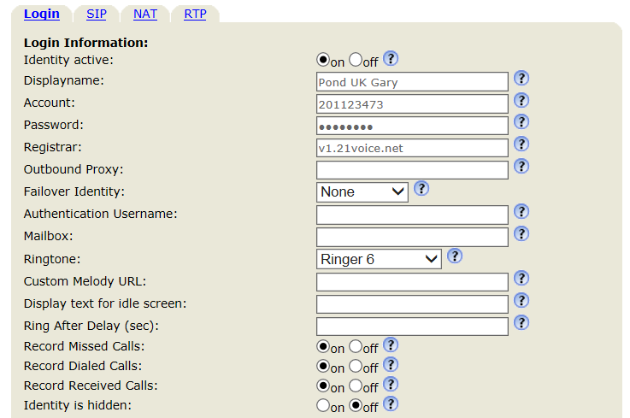

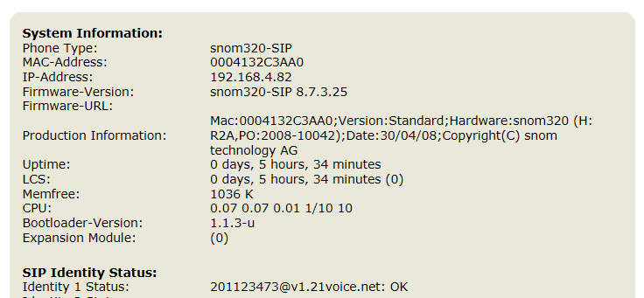

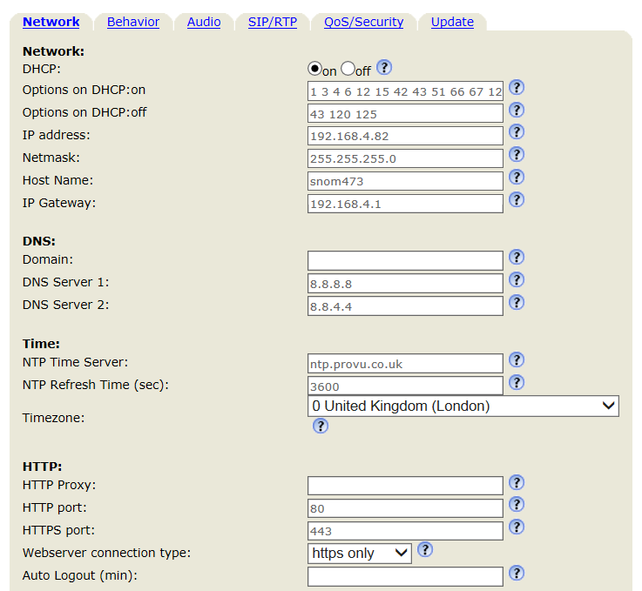

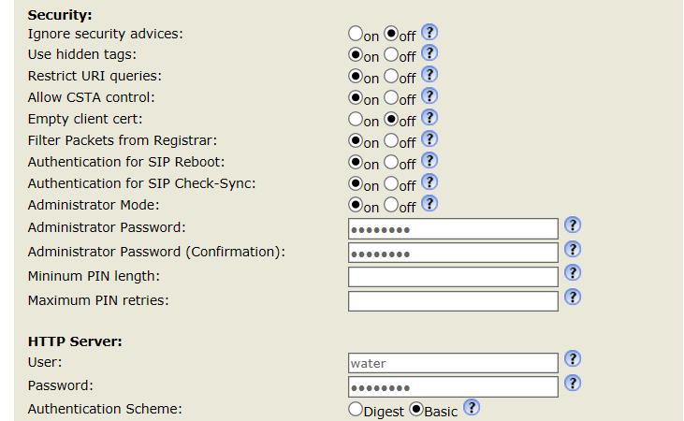

Administrator Password: 5050 HTTP Password: deep



