Computer Installation at Rebus
Updated: Monday, 7 August 2017 Contact: Alina Tabacaru

Business Address:
Rebus Construction Ltd
Located in the former Lamb Public House
The High Street
Hartley Wintney
Hampshire
RG27 8NW

Telephone: 01252 751000 or 01252 711477
Mobile: 07598 027159
Web: www.rebusconstruction.co.uk [Site under construction]
email: alina@rebusconstruction.co.uk

Router No.1 – VDSL2 Broadband Service from BT
Connected to: 01252 842186
Model Name: Vigor2860n – S/N 1660c3c3360 delivered 15/9/2016
Firmware Version: 3.8.2.3_BT
Build Date/Time: Apr 22 2016 19:28:07
Gateway: http://192.168.1.1 [00-1D-AA-F8-8B-30]
Router Userid: admin Password: darwin123 Remote WAN Access: http://81.133.89.9
WAN Username: 332283@hg7.btclick.com Password: Business1
WAN Fixed IP: 81.133.89.9
WAN Gateway: 81.148.96.1
DHCP: OFF
Wireless Services Turned: ON SSID: exlamb Password: route654

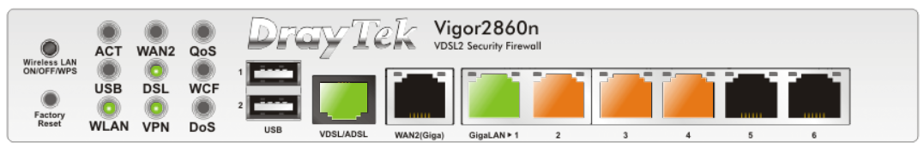
Port 1 – Link to 2830
Port 2 – snom 200923655 Ground Floor Office
Port 3 – snom 200923656 First Floor - Alina
Port 4 – snom 200923657 First Floor - Clynt, with link to his PC
Port 5 – Not in Use
Port 6 – TL-WPA4226 KIT [contains TL-WPA4220 and TL-PA4020P] – Client device located in printer room on the first floor. CAT5 connection made to Denise Metcalfe PC [Windows 7] with USB connection to HP Designjet 510 24” printer. On the PC, the printer is shared. Remote connections are allowed and password protection is turned off. Paper preference should be set to ISO A1 for drawings.
I don’t think the optional network card is installed. If that is the case I would recommend installing one. In doing so, there is no need to have a supporting PC left on all the time.
See: https://www.youtube.com/watch?v=eILjtsUxGUo
To Buy: http://www.ebay.co.uk/itm/HP-DESIGNJET-500-500PS-500-800-800PS-NETWORK-CARD-JET-DIRECT-CARD-ETHERNET-CARD-/251373324295 [£30.00]
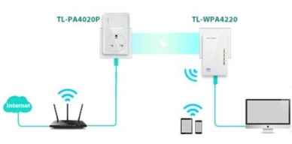
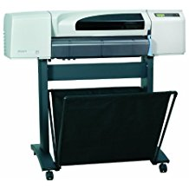

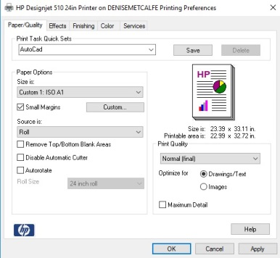
Router No.2 – VDSL2 Broadband Service from BT
Connected to: 01252 843230
Model Name: Vigor2830n
Firmware Version: 3.6.8.4_sb_232201
Build Date/Time: 2016/01/19 18:28:17
Gateway: http://192.168.1.250:8080 [00-50-7F-EC-C1-50]
Router Userid: admin Password: darwin123
WAN Username: 332284@hg57.btclick.com Password: Business1
WAN Service on Port: WAN2 BT Router is in modem mode
WAN Dynamic Allocation - Current Address: 81.151.136.175 [Sunday, 6 August 2017]
WAN Dynamic Gateway: 172.16.14.136
DHCP: ON
LAN: IP range start: 192.168.1.10 Pool Count: 99
Wireless Services Turned: ON SSID: Rebus Password: lam6

Routing [Tracert Checking]
Data Traffic uses default gateway 192.168.1.250
Set VoIP Traffic to use gateway 192.168.1.1

Configuration for snom phones
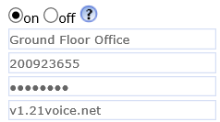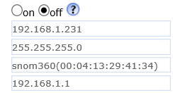

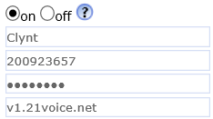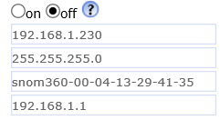

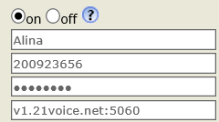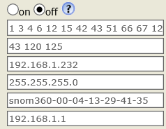

LAN Model WAN Type
192.168.1.1:80 Vigor2860n 81.133.89.9 Fixed
192.168.1.250:8080 Vigor2830n Varies Dynamic

Printers Wireless Connected unless otherwise stated.
192.168.1.15 [94-57-A5-7F-D0-4B] - HPF23872.home – HP Page Wide Pro 477dw MFP –
Model: D3Q 20B
192.168.1.20 [70-5A-0F-6A-94-DA] - HPICDE09 – HP Office 7610 – Model GIX85A
192.168.1.11 [00-80-92-B5-FE-0A] - BRW008092B5FE0A

BT Business Hub
http://btbusiness.custhelp.com/app/answers/detail/a_id/35226/~/how-do-i-enable-bridge-mode-on-my-bt-business-hub-5%3F

Enabling bridging mode on the BT Business Hub 5:
- On a PC or laptop connected to your hub, enter http://btbusinesshub.home or 192.168.1.254
- Click on Advanced Settings
- Enter your Admin password if prompted (can be found on the base of your Hub) and click Ok
- Click Continue to Advanced Settings
- Choose the Broadband tab, then click on the Routing tab
- Scroll down to the bottom of the page to Bridging
- Tick Yes next to Enabled
- If you're sure click Yes on the next screen
With the BT Business Hub now in bridge mode, configured the 2860 for PPPoE and entered the broadband credentials.

