Prepared by: David Bradley
Document: rogerbenham.docx

Technology Setup at 4 CY
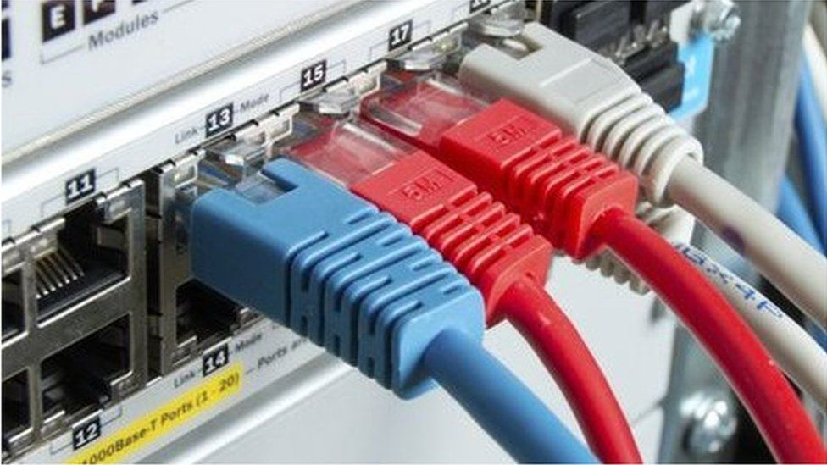
Roger Benham – Technology Setup at 4CY
Contact number: 07946 445865 Email: roger@mphem.net
Cloudscape Connect - 0116 274 7360 - FTTP Broadband Service
Router Make: ZYXEL VNG8623-TSOB V5.50 (ABPM.5)C0
Router Address: 192.168.1.1:8080
WAN Address: 92.62.0.101:8080
Router Userid: admin
Router Password: Route6542022*
Client DHCP Range: 192.168.1.2 ~ 192.168.1.251
Broadband Username: VFP1786189@cloudscape.uk
Broadband Password: Accept
Broadband Service: GTE8460 220/30 Mbps

SSID [2.5 GHz only]:
Name: Zyxel_88A1
Password: KYDLPQ7UC

Access URL: https://www.cloudscapeconnect.com/myaccount/
Account Number: 00009476
Username: RBrenham9476
Password: White912Orchid!

Cloudscape Connect email Service
Access URL: https://webmail.cldmail.co.uk/
email server: mail.cldmail.co.uk
email address/username: roger@cldmail.co.uk
Password: Route6542020

Voipfone - 150 or 020 7043 5555 – Help Desk
Registered email address: roger@cldmail.co.uk
Account Number: 30224454
Password: Benmr2675$
Memberable Word trolleybus

Summary of monthly financial commitment with VAT included:
Broadband from Cloudscape: £43.80 Broadband @ 220/30 Mbps
Voice Service from Voipfone Home 100: £5.00 Number - 01252 821 811
Total: £48.80

VoIP Number: 30224454
Password: 610785

Webmail service at: https://webmail.cldmail.co.uk

Inbound Server (POP3):
Server: mail.cldmail.co.uk
Port: 995 (use SSL)
Username: messages@cldmail.co.uk
Password: Route6542020

Outbound Server (SMTP):
The outbound mail server requires authentication.
Server: smtp.cldmail.co.uk
Port: 465 (use SSL or SSL/TLS)
Username: messages@cldmail.co.uk
Password: Route6542020

The following is no longer applicable until you see ***END***

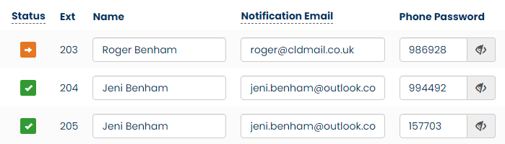

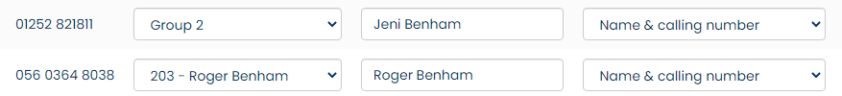

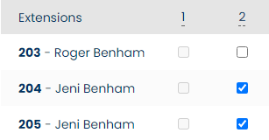

Configure Voicemails
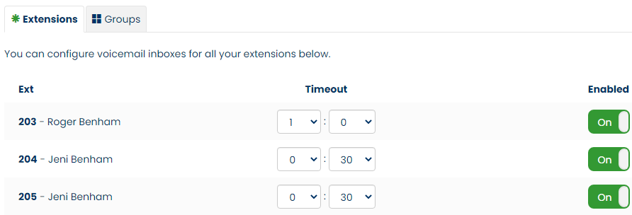

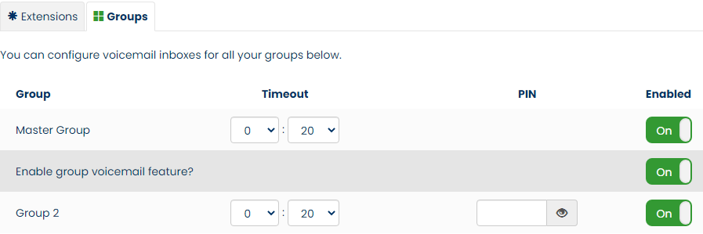

Call Diverts
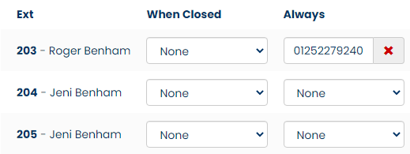

***END***
Making Outgoing Calls
You have opted to have a Digital Voice service from Voipfone by connecting your analogue telephone to Phone Port #1 of the router. Instead of being connected to the Farnham telephone exchange by an exclusive pair of copper wires, you are now utilising your broadband connection to a server located in London that supports voice traffic.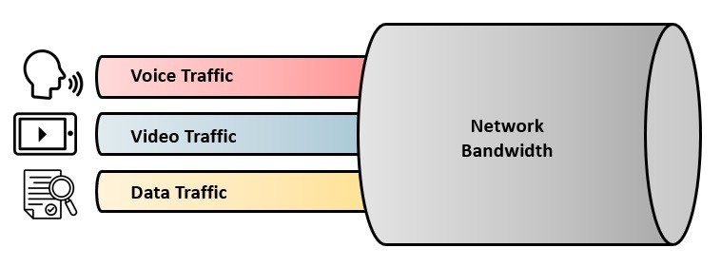
The quality of voice traffic can be affected by the volume of traffic on your internet connection while the call is in progress. However, your choice of a bandwidth of 220/30 Mbps shouldn’t experience this problem.
You use the phone in much the same way for outgoing calls as you always have done but there are subtle differences, like the need to use the area code every time you call a subscriber on the public telephone network and the fact that call waiting is active. Many features previously chargeable by other telephone providers are free when using Voipfone, like advanced voicemail.
The first digit you dial, routes the call accordingly:
Prefix | Action
0 | To another subscriber on the public telephone network
1 | A short code for various services provided by Voipfone (See Page 3) (Mostly free)
2 | Connects to another extension number on your local network (if any) FOC
3 | Connects to another subscriber on the Voipfone platform FOC
9 | Emergency Services
# | Special features and services available to you (See Page 3)
* | Commands on your local network
Call Rates
These can be found at: https://www.voipfone.co.uk/prices
About Voicemail vs Answerphone
You can choose between using the answerphone facilities with your phone or the Voicemail service from Voipfone. The latter is to be recommended. In a non-extension setup, the email address that messages left are sent to cannot be selected unless it is an extension. A single extension number attracts a monthly fee of £1.80.
Short Codes for Voipfone Users
Unless stated otherwise, all calls made using a short code are free

112 Emergency Services
999 Emergency Services
(See https://www.policeconduct.gov.uk/sites/default/files/Documents/research-learning/Silent_solution_guide.pdf)
101 Police Non-Emergency Number
111 NHS Mon-Emergency Number
105 Power Cut Information Line
116 999 Missing children helpline
116 111 NSPCC ChildLine
116 123 Samaritans
119 COVID-19 Help Line (Also used to make appointments)
123 Gives Day, Date and Time
141 Withhold your number (If you must – Not Recommended)
1470 Un-withhold your number
150 Voipfone Customer Services (Password protected service)
152 Echo test. Shows how good your connection to Voipfone is.
154 A recording of call credit left to use before top-up is necessary
155 Confirms that you have set up your phone correctly
159 Report a Banking Scam (See https://stopscamsuk.org.uk/159)
166 Voipfone Anti-Sales call tool (Optional monthly fee payable)
1280 Carrier pre-select disconnect from Voipfone (Only available to BT subscribers with pre-registration required)
1471 Plays back the last incoming number
1571 Voicemail for the extension you are using
1572 Voicemail for the Master Account (Used where your account does not have extension numbers)
1573 Voicemail for Group messages (Input the Group Number of Interest)
1995 Music on Hold (Listen to what is playing now)
## Transfer the call (Example ##01252758123 and hang up - Call charges may apply)
#0 Stops and starts call recording (Charged at 2.5 ppm)
** Generally used in business environments (Example **205 for call pickup from that extension)

Short Codes available from phones plugged into the ZYXEL VNG8623 router
These Speed Dial Numbers are setup in the router on this web page in the router configuration: VoIP >>> Call Rule

#01 1MH - Jim Rice - 07594340509
#02 2MH - Archie Bishop - 01252279323
#03 8WG - Sharyn Fitzpatrick-Nash - 01252279121
#04 4WG - David Bradley - 01252758960
#05 10WG - Peter Clappison - 01252727443
#06 Oliver Penfold [Gardner] - 07747749270
#07 Cloudscape Connect - 01162747360
#08 Voipfone Help Desk - 02070435555
#09 MPHEM Office - 30208619*200
#10 Swing Open the MH Gates - 07430525930

Security Console codes available when engaged in a conversation

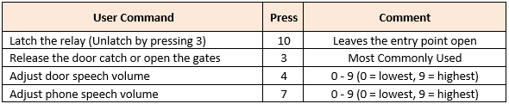
VoIP Settings in Router
SIP Account tab:
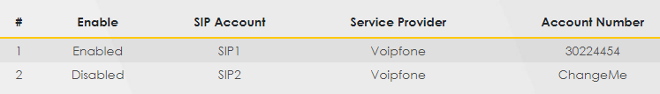
SIP Service Provider tab:
Phone Device tab:
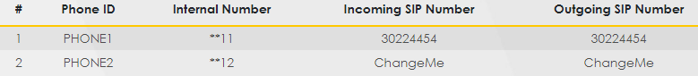
Region tab:
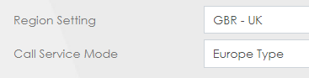
Call Rule:
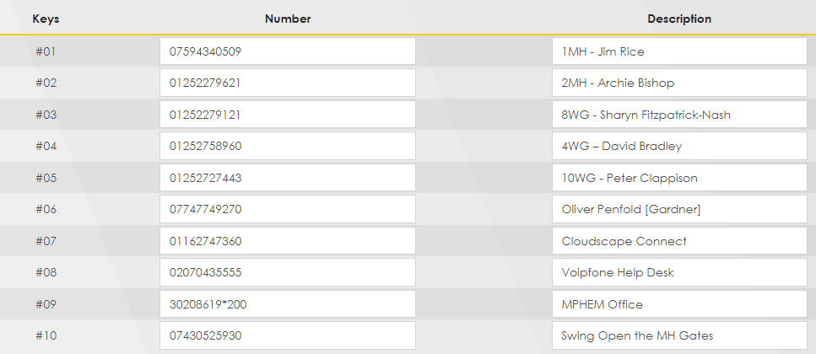
VoIP Status as at 14/10/22 at 19:43
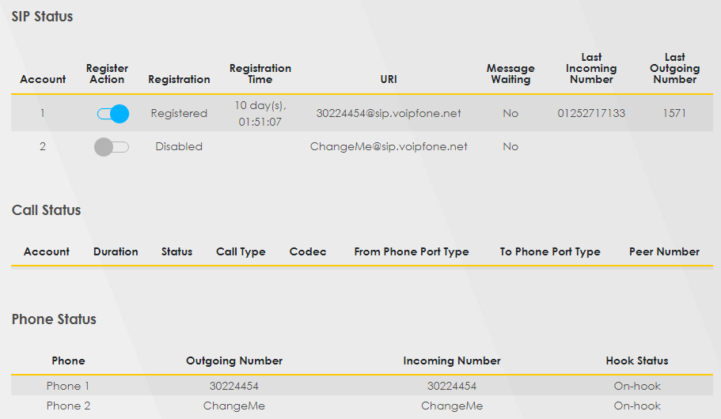

User Account
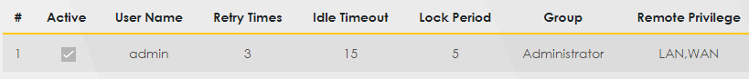

Remote Management
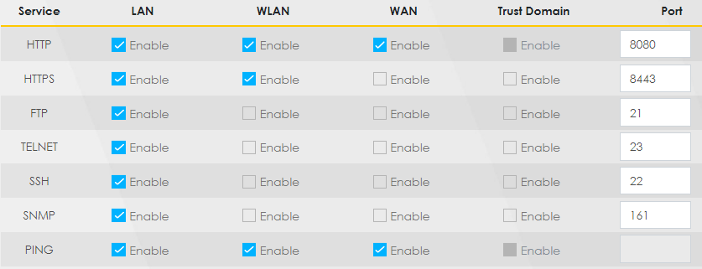

Time
