Prepared by: David Bradley
Document: terryrowland.docx
Terry Rowland – Technology Setup at 7WG
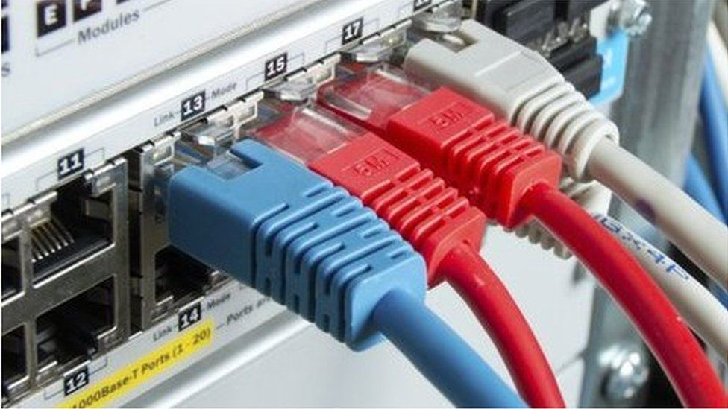
Terry Rowland – Technology Setup at 4WG
Contact number: 07746 728 455 email: terryjoan@cldmail.co.uk
Service: 220/30
Cloudscape Connect - 0116 274 7360 - FTTP Broadband Service
Router Make: ZYXEL DX3301-T0
Router Address: 192.168.42.1
Client DHCP Range: 192.168.42.42 to 84
Broadband Username: VFP2108853@cloudscape.uk
Broadband Password: gu101fa
WAN Address: 92.62.0.231

SSID [2.5 GHz]: wg724 Password: SimpleOne2024^
SSID [5 GHz]: wg724 Password: SimpleOne2024^
SSID [Guest]: wg724 guest Password: [WelcomeAboard]
Account URL: https://www.cloudscapeconnect.com/myaccount/
Account Number: 9687
Username: TRowland9687
Password: Bangle229Triple
Broadband Service: FTTP 220/30

Cloudscape Connect email Service
URL: https://webmail.cldmail.co.uk/
Server inbound: mail.cldmail.co.uk Server outbound: smtp.cldmail.co.uk
email address/username: terryjoan@cldmail.co.uk
Password: Route6542020*

Voipfone - 150 or 020 7043 5555 - Digital Voice Service [VoIP]
Registered email address: terryjoan@cldmail.co.uk
Password: Route6542020
Account Number: 30229316 Password: 783778
Memorable Word: david Hint: set up by
Extensions: 4
Voipfone provisioning: 05603 663 346
Tele Number: 01252 279 331

Access to Router – ZYXEL DX3301-T0
Local URL: 192.168.42.1:8080
Remote URL: http://92.62.0.231/login
Username: admin
Password: elstead2008
When the logon screen is locked, it takes 30 minutes to clear

Voipfone Standing Charges per Month
Renewal of UK Geographic Number 01252279331 1 £3.00 £3.00
Renewal of Virtual PBX Extension(s) 4 £1.50 £6.00
VAT @ 20% £1.80
Total £10.80

Cloudscape Standing Charges per Month
Broadband & Internet Services £28.10
VAT @ 20% £5.62
Total £33.71

BT email Service Fee per Month – Required?
To retain existing email address into Outlook £7.50
VAT @ 20% £1.50
Total £9.00

Monthly Commitment £53.51

Gate Intercom Codes
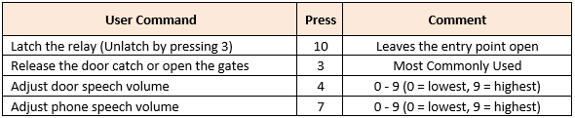

Setting in Gate Security Console as at 15/SEP/2023
WG Gate  07430 525 931 |  | Entry Code  1213 Enter |  |  | GU10 1FA
nnn  [Circuit] | Name | Appt | Primary  STN | Divert  STD / STE | Dial in Access  STR | Fob Issue  FOB
007  037 | Joan Rowlan  Terry Rowland | 7WG  . | 07845 474940  07746 728455 | 01252 279 331  . | .  . | 123,13632  246,18545
Option not set: The primary number rings simultaneously a group of numbers. No need for a divert facility.

System Wide Short Codes on the Voipfone Platform
Unless stated otherwise, all calls made using a short code are free

112 Emergency Services
999 Emergency Services
(See https://www.policeconduct.gov.uk/sites/default/files/Documents/research-learning/Silent_solution_guide.pdf)
101 Police Non-Emergency Number
111 NHS Mon-Emergency Number
105 Power Cut Information Line
116 999 Missing children helpline
116 111 NSPCC ChildLine
116 123 Samaritans
119 COVID-19 Help Line (Also used to make appointments)
123 Gives Day, Date and Time
141 Withhold your number (If you must – Not Recommended)
1470 Un-withhold your number
150 Voipfone Customer Services (Password protected service)
152 Echo test. Shows how good your connection to Voipfone is.
154 A recording of call credit left to use before top-up is necessary
155 Confirms that you have set up your phone correctly
159 Report a Banking Scam (See https://stopscamsuk.org.uk/159)
166 Voipfone Anti-Sales call tool (Optional monthly fee payable)
118 797 Connects to BT's Directory Enquiry services (Very expensive to use)
1280 Carrier pre-select disconnect from Voipfone (Only available to BT subscribers with pre-registration required)
1471 Plays back the last incoming number
1571 Voicemail for the extension you are using
1572 Voicemail for the Master Account (Used where your account does not have extension numbers)
1573 Voicemail for Group messages (Input the Group Number of Interest)
1995 Music on Hold (Listen to what is playing now)
## Transfer the call (Example ##01252758123 and hang up - Call charges may apply)
#0 Stops and starts call recording (Charged at 2.5 ppm)
** Generally used in business environments (Example **205 for call pickup from that extension)

Short Codes available via the Voipfone app or analogue phone connected to the ZYXEL VNG8623 router

200 Terry’s Mobile Phone
201 Joan’s Mobile Phone
202 Desktop/Wireless Phone
203 Desktop/Wireless Phone

Short Codes available to phones plugged into your ZYXEL VNG8623 router
Speed Dial Numbers setup in the router on this page: VoIP >>> Call Rule

#01 07733455827 Lorraine Denny
#02 01252712485 Annie Bishop [Private VoIP]
#03 01252279223 Roger Benham [Private VoIP]
#04 01252758960 David Bradley [Private VoIP]
#05 07771904536 Diana Rowland
#06 01252279986 Stephen Gibson [Private VoIP]
#07 01162747360 Cloudscape Connect
#08 02070435555 Voipfone Help Desk
#09 01622739117 Heather Wormald
#10 07430525931 Swing Open the WG Gates – When call answered, press 3

