Internet & Telephone Services Information Sheet
Instant Information Page

Voipfone
Customer Services Telephone Number: 020 7043 5555 from any phone or short code 150 from the snom phone
URL: https://my.voipfone.co.uk/#!/dashboard+auth
Logon: allan@bumpsandscuffs.com
Account: 30213872
Memberable Word: Gartmore
Tele Password: 079847
Account Password: Dalmary24217&

Cloudscape
Customer Services Telephone Number:
URL: https://www.cloudscapeconnect.com/myaccount/
Username: allan@bumpsandscuffs.com
Password: Dalmary24217

Web Site Designer

URL: www.bumpsandscruffs.com
Andrew Howard [mailto:andrew@imarketingonly.com]
Office: 020 8123 4164
Mobile: 07798 554 540
MacDonald Ryan Ltd T/A Bumps and Scuffs
45 The Street Tilford Road, Rushmoor
Wrecclesham - And At - Farnham
GU10 4QS GU10 2EP

Allan Macdonald <allan@bumpsandscuffs.com> Mobile: 07764 623 636
Registered Address: 6 Maultway Crescent, Camberley, Surrey, GU15 1PN
Website: https://www.bumpsandscuffs.com/

Overview for Wrecclesham and Rushmoor Locations

Type | Public Telephone Number | B&S Extension | Comment
VoIP | 01252 217 085 | 209 | Number Used on Leaflet Promotions
VoIP | 01252 217 086 | 208 | Number Advertised on the Bumps & Scuffs Web Site
VoIP | 01252 217 087 | 210 | Number Shown on Business Stationery
VoIP | 01252 279 750 | 206 | Bodyshop at Rushmoor  One receiver in the office the other in the bodyshop. Forced CLI set to 01252 279 750
VoIP | 05603 874 561 | 200 | David Bradley [Telephone Service Support]
VoIP | 01252 794 700 | 211 | Landline previously at Rushmoor now at Wrecclesham
VoIP | - | 212 | Rushmoor Car Showrooms
VoIP | 01252 444 664 | 202 | Possible IVR Use

Notes:
- Potential and existing customers will use the telephone number shown on the web site, stationery, or the former number at Rushmoor
- Numbers shown in green will ring the snom desk phone at Wrecclesham; those in red will ring the wireless phones at Rushmoor
- Incoming calls at Wrecclesham on the snom phone can be transferred to Rushmoor
- All VoIP phones have business hours applied as shown next

Extensions showing business hours at Rushmoor and Wrecclesham
- Any messages left can be retrieved by dialling 1571 or listening to the attachment sent by email to info@bumpsandscuffs.co.uk
- To call Wrecclesham outside business hours dial 01252 444 664
- To call Rushmoor Bodyshop during business hours, dial 206 from the snom or 01252 279 750 from any phone
- To call Rushmoor Showrooms (Peter/Anna) dial 212 from either Wrecclesham or Rushmoor
- If the Internet goes down, VoIP calls can be directed to a mobile number of your choice.
- Calls between extensions are free of charge
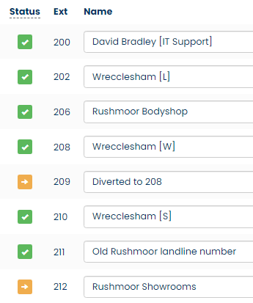
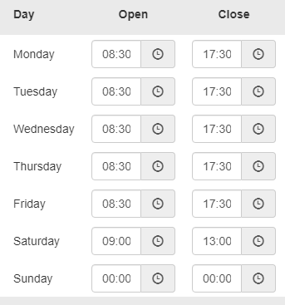

Voipfone - Contact Number: 020 7043 5555 from any phone or short code 150 from a VoIP phone
Common account for Wrecclesham and Rushmoor
Not in contract and technically free to leave at any time, but there are procedures to follow to move to another supplier
URL: https://my.voipfone.co.uk/#!/dashboard+auth
Logon: allan@bumpsandscuffs.com
Account: 30213872
Password: 079847
Account Password: Dalmary24217&
Memberable Word: Gartmore

Recurring Charges seen for November 2022
Item Quantity Cost Total
Cloud Call Recording 1 £10.000 £10.000
UK Geographic Number 01252217085 1 £3.000 £3.000
UK Geographic Number 01252217086 1 £3.000 £3.000
UK Geographic Number 01252217087 1 £3.000 £3.000
UK Geographic Number 01252279750 1 £3.000 £3.000
UK Geographic Number 01252444664 1 £3.000 £3.000
UK Geographic Number 01252794700 1 £3.000 £3.000
Virtual PBX Call Group 1 £1.000 £1.000
Virtual PBX Extensions 9 £1.500 £13.500
Storage Fee For 1798 Minutes 1 £0.890 £0.890
VAT @ 20% £8.68
Total £52.07

Call Top-up
The monthly standing charges are collected from the debit card held on file by Voipfone. A call deposit is required to make calls out onto the public network. When the call deposit drops to below £2 it is auto-topped up by £50. Historically it lasts about five months equivalent to £10 to £11 a month. A call plan was in place with OneCom for 1000 Minutes at £19.75 + VAT.
System Wide Short Codes on the Voipfone Platform
Unless stated otherwise, all calls made using a short code are free

112 Emergency Services
999 Emergency Services
(See https://www.policeconduct.gov.uk/sites/default/files/Documents/research-learning/Silent_solution_guide.pdf)
101 Police Non-Emergency Number
111 NHS Mon-Emergency Number
105 Power Cut Information Line
116 999 Missing children helpline
116 111 NSPCC ChildLine
116 123 Samaritans
119 COVID-19 Help Line (Also used to make appointments)
123 Gives Day, Date and Time
141 Withhold your number (If you must – Not Recommended)
1470 Un-withhold your number
150 Voipfone Customer Services (Password protected service)
152 Echo test. Shows how good your connection to Voipfone is.
154 A recording of call credit left to use before top-up is necessary
155 Confirms that you have set up your phone correctly
159 Report a Banking Scam (See https://stopscamsuk.org.uk/159)
166 Voipfone Anti-Sales call tool (Optional monthly fee payable)
118 797 Connects to BT's Directory Enquiry services (Very expensive to use)
1280 Carrier pre-select disconnect from Voipfone (Only available to BT subscribers with pre-registration required)
1471 Plays back the last incoming number
1571 Voicemail for the extension you are using
1572 Voicemail for the Master Account (Used where your account does not have extension numbers)
1573 Voicemail for Group messages (Input the Group Number of Interest)
1995 Music on Hold (Listen to what is playing now)
## Transfer the call (Example ##01252758123 and hang up - Call charges may apply)
#0 Stops and starts call recording (Charged at 2.5 ppm)
** Generally used in business environments (Example **205 for call pickup from that extension)

In-Call Feature Codes

## Used to transfer a call if your telephone doesn't have a transfer button
#0 Starts and stops call recording (charged at 2.5p pm). Log into your account to listen to any messages left.
#1 Places call on hold. Use # to cancel. (This is NOT the same as DND)
Wrecclesham Setup

Cloudscape Connect – Contact Number: 0116 274 7360
Provider of Broadband Service only. Fibre 80:20 Line Identification: GTE8059

URL: https://www.cloudscapeconnect.com/
Address: Unit Q, Troon Way Business Centre, Humberstone Lane, Leicester, LE4 9HA
Account number: 00009414
DSL Username: VFS100349@cloudscape.uk – DSL Password: gu104qs
WAN address: 92.62.0.60
Contract End Date: 13/08/2022
Help Desk: 0116 274 7360
Opening Hours: 9am - 7pm, Monday – Friday
Via Email: support@cloudscapeconnect.co.uk
Via SMS: Text the word "Help" followed by a description of your problem to 07786 209609
Support Portal: https://support.cloudscapeconnect.com/
Account access: https://www.cloudscapeconnect.com/myaccount/
Userid: allan@bumpsandscuffs.com
Password: Dalmary24217
Line Identification: GTE8059

Item Price Notes
FTTC Broadband 80:20: £30.60 [GMS 35Mbps down, 10Mbps up]
Care Level 2: £0.00 Comes as standard
Total: £30.60 Price includes VAT

Care Level 2 is the response time provided by Openreach to fix a fault which for this level of care means a fix by the end of the next day Monday to Saturday. Faster response times available but at a premium cost to have the service up and running within six hours. Indicative price of £90 + VAT a year.
If the broadband service is lost, voice calls are automatically diverted to 07818 076372 at no cost but call leg charges apply.
For internet continuity during a loss of the broadband service is possible by using 4G but that would mean replacing the existing router and a separate contract for the SIM card.

Router Access [Defaults on label changed as shown below}:
Router IP: 192.168.33.1 Not as shown on router label
Router Login: admin Password: elstead2008* Not as shown on router label
LAN IP range start: 192.168.33.33 Pool Count = 20
VPN: Connection Name: B&S-Wrecclesham Userid: david Password: gu101fa
WAN IP: 92.62.0.60
SSID 2.4Ghz: B&S-Wrecclesham Password: route6542021

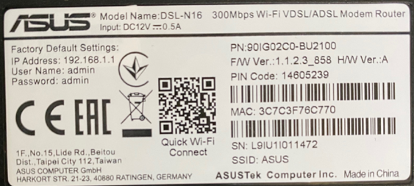

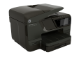
HP Officejet Pro 276dw MFP
Host Name: HP46B501
IP Address: 192.168.33.39
email: BandS@cldmail.co.uk
Serial Number: CN51ACV0WK

The printer can send distress emails to a nominated email address. Therefore, the email account bands@cldmail.co.uk has been created and used within the printer’s GUI - SETTINGS >> Email Alerts
The printer cannot accept inbound mail, but email error message can be found using the Webmail service at: https://webmail.cldmail.co.uk - User Name: bands@cldmail.co.uk Password: Route6542020

Outbound Server (SMTP):
The outbound mail server requires authentication.
Server: smtp.cldmail.co.uk Port: 465 (use SSL or SSL/TLS)
Username: bands@cldmail.co.uk Password: Route6542020
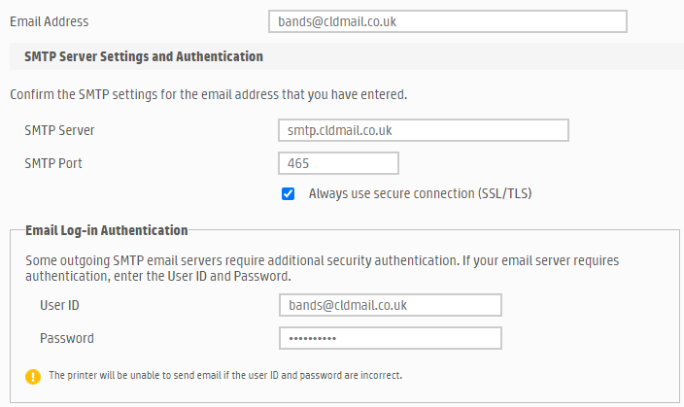
Snom Phone at Wrecclesham
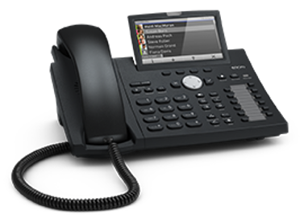
Press the ‘?’ key to determine current IP address
IP Address: 192.168.33.37
Userid: trolleybus
Password: route654
MAC: 00:04:13:95:44:5F
Picture: http://cyberpictures.net/castlestreet2.jpg

Peter
217086
444664
217086
Rushmoor
217085
Allan [M]
794700
Craig [M]
217087
David
217087
Cut out the label and replace the existing one making sure the plastic cover is not lost!

Devices Seen on the Network on Wednesday, 29 September 2021
All devices use DHCP and therefore the IP address shown in the table below may be different in the future

Host Name | IP Address | MAC Address | Device
HP46B501 | 192.168.33.36 | 6C:C2:17:50:79:89 | HP Officejet Pro 276dw MFP
BandS Lenovo | 192.168.33.37 | 44:8A:5B:DE:7A:63 | Desktop PC
snomD375-95445F | 192.168.33.33 | 00:04:13:95:44:5F | Snom D375 VoIP phone
81490621 | 192.168.33.34 | 54:E1:40:0B:8F:0F | Credit Card Machine
Craigs-iPhone | 192.168.33.35 | 4A:3F:43:BC:83:9C | Mobile Phone
Cindys-iPhone | 192.168.33.xx | CA:FE:EE:1D:0C:29 | Mobile Phone
 | 192.168.33.38 | BE:EF:FE:90:C5:93 | Unable to determine device

Running costs of Telecommunications and Broadband Services across the two sites per month

Voipfone rental for the phones. From Page 4: £52.07
Voipfone call charges. Call deposit of £50 usually last 3 months: £17.00
Broadband at Wrecclesham. From Page 6: £30.60 Out of Contract
Broadband at Rushmoor. From Page 12: £30.60 In contract till 25th July 2024
Total including VAT at 20%: £130.27

- The setup supports six numbers one of which is at Rushmoor.
- There are free calls between sites and other Voipfone users. Calls to 01/02/03 numbers cost 1.2 ppm.
- No fixed annual price rises from either Voipfone or Cloudscape although an increase is to be expected as their costs rise.
- The monthly cost is equivalent to what was previously paid at Wrecclesham to OneCom + FleXtel up until 2021 for just a service there. Incorporating the Rushmoor site with a Broadband and phone service has not cost more.
- Superior Help Desk facilities from both Cloudscape and Voipfone in comparison to other main stream providers.

Before and After at Wrecclesham

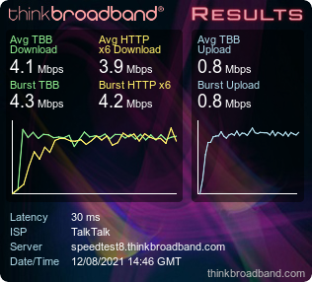 |  | 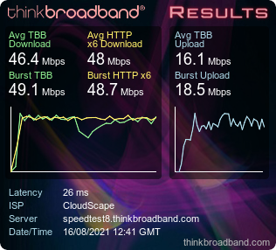
Former Service from OneCom  The base cost for this service was £43.25 |  | Current Service from Cloudscape  The base cost for this service is £30.60

Rushmoor Setup

Cloudscape Connect – Contact Number: 0116 274 7360
Provider of Broadband Service only. SoGEA Fibre 80:20 Line Identification: GTE9274

URL: https://www.cloudscapeconnect.com/
Address: Unit Q, Troon Way Business Centre, Humberstone Lane, Leicester, LE4 9HA
Account number: 00009414
DSL Username: VFS504267@cloudscape.uk (SoGEA) - Password: gu102ep
WAN address: 92.62.0.199
Help Desk: 0116 274 7360
Opening Hours: 9am - 7pm, Monday – Friday
Via Email: support@cloudscapeconnect.co.uk
Via SMS: Text the word "Help" followed by a description of your problem to 07786 209609
Support Portal: https://support.cloudscapeconnect.com/
Account access: https://www.cloudscapeconnect.com/myaccount/
Userid: allan@bumpsandscuffs.com
Password: Dalmary24217
Line Identification: GTE9274

Item Price Notes
SoGEA Broadband 80:20: £30.60 [GMS -- Mbps down, -- Mbps up]
Care Level 2: £0.00 Comes as standard
Total: £30.60 Price includes VAT

SSID 2.4Ghz: RushmoorBodyshop Password: route6542023* LAN IP range start: 192.168.30.30 to 50
SSID 5Ghz: -ditto-

Rushmoor Router
IP: 192.168.30.1
Login: admin
Password: Trolleybus654*

VoIP
CLI on this line: 01252 279 750
VoIP extension number: 206
VoIP Password: 262635
Prefix: 30213872
Memberable Word: Gartmore

Speed Test for this SoGEA service on the 25th July 2023

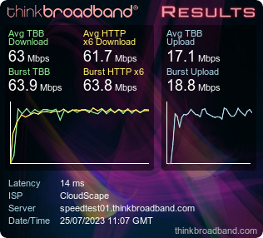
Service currently supports just VoIP and devices connected to the WiFi although many computers could be connected if the need arises.

Voipfone Hosted Phone service (serving both your sites)
Item | Quantity | Cost | Total
Renewal of Cloud Call Recording | 1 | £10.000 | £10.000
Renewal of UK Geographic Number 01252217085 | 1 | £3.000 | £3.000
Renewal of UK Geographic Number 01252217086 | 1 | £3.000 | £3.000
Renewal of UK Geographic Number 01252217087 | 1 | £3.000 | £3.000
Renewal of UK Geographic Number 01252279750 | 1 | £3.000 | £3.000
Renewal of UK Geographic Number 01252444664 | 1 | £3.000 | £3.000
Renewal of UK Geographic Number 01252794700 | 1 | £3.000 | £3.000
Renewal of Virtual PBX Call Group | 1 | £1.000 | £1.000
Renewal of Virtual PBX Extension(s) | 9 | £1.500 | £13.500
Storage Fee For 1246 Minutes | 1 | £0.630 | £0.630
VAT @ 20% |  |  | £8.63
Total |  |  | £51.76

A call deposit of £50 was made on these dates:
05/03/2024
15/08/2023
22/03/2023
Over a year your call costs were £150, which is about £12.50 a month

Phone Usage for June 2024 shown below which is probably typical for each month
Total number of incoming calls: 296 Total call duration: 6:50:49
Total number of outgoing calls: 146 Total call duration: 3:55:46 Total call cost: £6.96

Cloudscape for the Internet
Broadband Services at Wrecclesham and Tilford: £51.00 No Phone service provided
VAT @ 20% £10.20
INVOICE TOTAL: £61.20

Totals
VoIP Provision: £51.76
Average call costs per month: £12.50
Broadband for two sites: £61.20
Cost per month: £125.46

Historical Information

FleXtel Limited
Address: FleXtel House, The Commons, Sandbach, Cheshire, CW11 1EG
URL: https://www.flextel.com/secure/
Account Number: A250963
Password: calum123
Telephone ID: 1895 6468
Help Desk:
Tel: 0370 321 1000
Email: ask@flextel.com
Hours: Monday - Friday 09:00 - 17:00

OneCom Ltd - Contact Number: 03300 888 999
Provider of Broadband and Voice Service on 01252 444 664
With the migration of the number to Voipfone, there is no longer a service from OneCom
OneCom office hours: Monday to Friday 09:00 - 17:00
URL: onecom.co.uk
Address: OneCom House, 4400 Parkway, Solent Business Park, Fareham, PO15 7FJ
Account Number: 2028049

Former charges:
OneCom for ADSL2+ Broadband and Phone Service £78.90
FleXtel average monthly cost: £50.00
At the time, the Rushmoor Bodyshop did not exist £0
Total: £128.90 Includes VAT

Rushmoor Setup

TalkTalk at Rushmoor - Contact Number: 0800 083 3003
Provider of Broadband and Voice Service on 01252 447030

Account number: 882 01552852
DSL Username: 01252447030@talktalkbusiness.net – DSL Password: H6R4V4Q6G3
WAN address: 92.27.221.10
Contract End Date: 21/07/2023

TalkTalk ‘MyAccount’ Information
URL: https://supportcentre.talktalkbusiness.co.uk/SCLogin
Logon email address: info@bumpsandscuffs.com
Security password: Thea2018 [Case sensitive]
Pin: 5012 [No idea when and where this is used]
File contact numbers: 01252 217087 and 07836547472
Security Question: Where were you born? Answer: Richmond

7 Day Business Support £0.00
CLI Retrieval (1471) Basic £0.00 }
Caller Display £0.00 } Land Line not used
Reminder Call Basic £0.00 }
Fibre Line Rental £ }
Simply Fibre Business Broadband £12.00
Fibre Discount 500 £-5.00
£
VAT @ 20% £
£ Previous contract period was £26.26 – Estimated price from April 2022 - £31.35

TalkTalk
Customer Services Telephone Number: 0800 083 3003
URL: https://supportcentre.talktalkbusiness.co.uk/SCLogin
Logon: info@bumpsandscuffs.com
Security password: Dalmary24217
Pin: 5012 [No idea when and where this is used]
Contact numbers: 01252 217087 and 07836547472
Security Question: Where were you born? Answer: Richmond
Account Number: 882 01552852
Physical Number: 01252447030
Account Password: trolleybus

