4 The Walled Garden, Farnham, Surrey, GU10 1FA
Tele: 01252 758960 email: david@cyberpictures.net
Mobile: 07836 547472 Voipfone 30204177*204

INVOICE #9500

Tuesday, 06 April 2021

Mike Morgan
Midhurst Engineering
Rumbolds Hill
Midhurst
GU29 9DD

To Services Rendered from 28th March 2020 to 6th April 2021
Reimbursement of Calls Made
Date & Time | From | To | Duration | Call Cost
28/03/2020 15:46 | 30204177*201 | 01730888276 | 4 | £0.00
28/03/2020 15:49 | 30204177*201 | 07860591810 | 271 | £0.54
28/03/2020 15:54 | 30204177*201 | 07860591810 | 21 | £0.04
28/03/2020 18:26 | 30204177*201 | 07860591810 | 219 | £0.44
28/03/2020 18:33 | 30204177*201 | 07860591810 | 35 | £0.07
28/03/2020 19:10 | 30204177*201 | 07860591810 | 1040 | £2.08
 |  |  | Ex Vat | £3.17
 |  |  | inc VAT | £3.81 | £3.81
Remote Session to connect Mike’s home network to Rumbolds Hill  Add the Office printer sourcing the correct driver  Applying the latest MS Updates  Updating Malwarebytes and TeamViewer  Say 3 hours @ £30 per hour |  |  |  |  | £90.00
Carried Forward £93.81
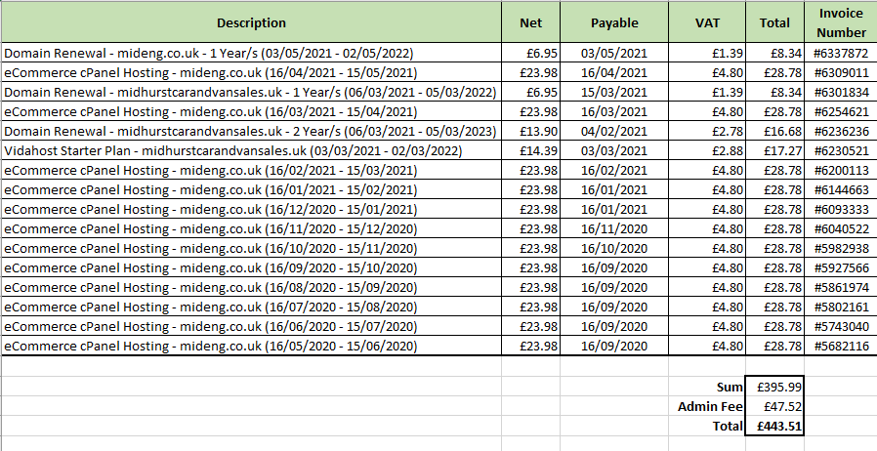
Payments made to TSOHOST + Commission Sharing
Amount Due: B/F £93.81 + £443.51 = £537.32

With compliments
David Bradley

Payment by BACS please to:
Sort Code: 40-47-86
Account Number: 64418050
Account Name: D C Bradley (Private Account)
Payment Reference: 9500

