4 The Walled Garden, Farnham, Surrey, GU10 1FA
Tele: 01252 758960 email: david@cyberpictures.net

Expenses Claim
Saturday, 23 February 2019

Moor Park House Estate Management Ltd
The Walled Garden,
Farnham,
Surrey,
GU10 1FA

Expense Claim

Setting up a Virtual telephone system with Voipfone £67.97 ---------
Total now due £67.97 =====

Total due to cover these invoices (hardcopies will be provided):

1012740011 | 23/02/2019 | £0.43
1012732821 | 15/02/2019 | £5.00
1012720311 | 04/02/2019 | £1.20
1012720308 | 04/02/2019 | £1.20
1012719681 | 04/02/2019 | £15.60
1012710800 | 25/01/2019 | £5.00
1012702640 | 17/01/2019 | £5.00
1012696501 | 11/01/2019 | £5.00
1012693893 | 09/01/2019 | £2.07
1012693890 | 09/01/2019 | £1.03
1012689315 | 05/01/2019 | £12.00
1012678425 | 22/12/2018 | £0.55
1012678424 | 22/12/2018 | £1.11
1012667259 | 11/12/2018 | £0.99
1012667218 | 11/12/2018 | £1.99
1012662556 | 06/12/2018 | £2.40
1012662555 | 06/12/2018 | £2.40
1012662553 | 06/12/2018 | £5.00
With Compliments

Sort Code: 40-47-86
Account Number: 64418050
Account Name: D C Bradley
Payment Reference: VOIP12-2
Information

Ongoing number and features charge each month £19.20
Probable call spend each month across all extensions £5.00

Calls from Archie’s phone amounts to £15.79.

Extension to Extension calls are free.
Calls to 01/02/03 numbers are 1.2ppm
Calls to UK mobiles are 12ppm

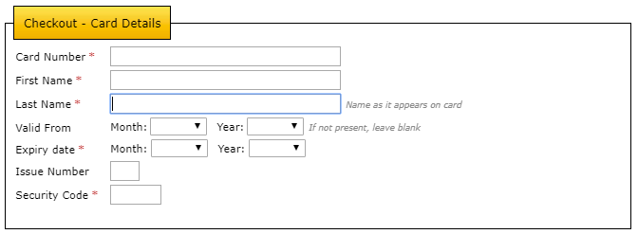

Important: Changing the card details will require your credit card to be validated. A temporary 50p charge will be made (and refunded immediately), in order to verify that the address and card details match.

