4 The Walled Garden, Farnham, Surrey, GU10 1FA
Tele: 01252 758960 email: david@cyberpictures.net
Mobile: 07836 547472 Draytel: 8234842

INVOICE 9360

Sunday, 11 March 2018

Neil Sallis
Robanes Limited,
30 Hollingworth Court
Turkey Mill
Ashford Road
Maidstone
Kent
ME14 5PP

Expenses made on behalf of the Company to Vidahost

22 September 2016 | #810526 | Unlimited Plan - 13/10/2016 - 12/11/2016 * | £19.99
23 October 2016 | #827062 | Unlimited Plan - 13/11/2016 - 12/12/2016 * | £19.99
22 November 2016 | #842579 | Unlimited Plan - 13/12/2016 - 12/01/2017 * | £19.99
23 December 2016 | #858113 | Unlimited Plan - 13/01/2017 - 12/02/2017 * | £19.99
23 January 2017 | #875302 | Unlimited Plan - 13/02/2017 - 12/03/2017 * | £19.99
20 February 2017 | #892675 | Unlimited Plan - 13/03/2017 - 12/04/2017 * | £19.99
17 March 2017 | #910101 | Unlimited Plan - 13/04/2017 - 12/05/2017 * | £19.99
13 April 2017 | #927068 | Unlimited Plan - 13/05/2017 - 12/06/2017 * | £19.99
14 May 2017 | #944972 | Unlimited Plan - 13/06/2017 - 12/07/2017 * | £19.99
13 June 2017 | #962633 | Unlimited Plan - 13/07/2017 - 12/08/2017 * | £19.99
14 July 2017 | #980124 | Unlimited Plan - 13/08/2017 - 12/09/2017 * | £19.99
14 August 2017 | #997192 | Unlimited Plan - 13/09/2017 - 12/10/2017 * | £19.99
08 September 2017 | #1014179 | Unlimited Plan - 13/10/2017 - 12/11/2017 * | £19.99
14 October 2017 | #1031841 | Unlimited Plan - 13/11/2017 - 12/12/2017 * | £19.99
13 November 2017 | #1048442 | Unlimited Plan - 13/12/2017 - 12/01/2018 * | £19.99
14 December 2017 | #1064703 | Unlimited Plan - 13/01/2018 - 12/02/2018 * | £19.99
14 January 2018 | #1082776 | Unlimited Plan - 13/02/2018 - 12/03/2018 * | £19.99
15 February 2018 | #1100872 | Unlimited Plan - 13/03/2018 - 12/04/2018 * | £19.99
 |  |  | £359.82
 |  | Activity Fee | £53.97
 |  | Total | £413.79

Notes:
- The domain name registration fee, expiring on 12th August 2026, has been paid.
- Invoices shown are for hosting the domain name robanes.com SEP16-FEB18
- * Indicates includes VAT
- # Indicates Vidahost’s invoice number
- See separate zip file for copies of Vidahost invoices covering SEP16-FEB18
- Where other organizations are shown on the same invoice, they have been ignored
- Service details shown below
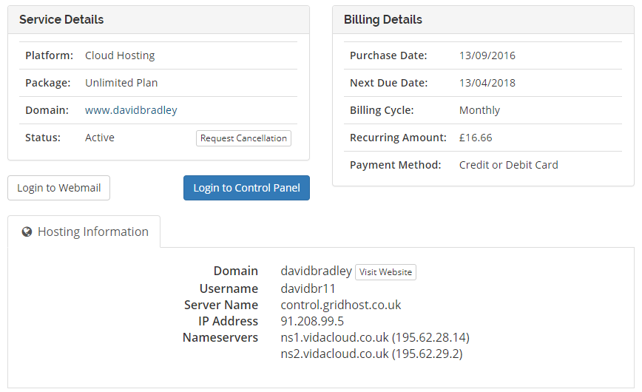
- The recurring amount seen excludes VAT
- Confusingly the Domain showing “davidbradly” really means the account holder.
From the Hosting Information above use:
URL: https://control.gridhost.co.uk/members/
Username: davidbr11
Password: ,nL7%PyT~fNV
The Cloud Hosting Platform for robanes.com appears giving complete control of hosting facilities although the only feature currently being used is ‘Emails’

With compliments
David Bradley

Payment by BACS acceptable to:
Sort Code: 40-47-86
Account Number: 64418050
Account Name: D C Bradley
Payment Reference: 9360

